Password Cracking & Credential Attack Suite

Project Title
Password Cracking & Credential Attack Suite

Internship Organization:
Unified Mentor.Com

Duration:
6 Months Internship

Year:
2026

Project Report Submitted By
Name: Arshi

Technology Used
- Python
- Passlib
- Hashlib
- Python-Docx
- ReportLab

Abstract
Passwords are the primary mechanism used to secure user accounts and digital systems. However, weak password practices continue to be one of the leading causes of security incidents, account compromises, and unauthorized access.
The Password Security Audit Toolkit is a Python-based cybersecurity project designed to help users understand password security principles and evaluate password quality through defensive security assessments. The toolkit includes modules for password wordlist generation, hash analysis, password strength evaluation, and security audit report generation.
The project focuses on cybersecurity awareness, password policy assessment, and secure authentication practices in controlled educational environments.

Introduction
Authentication plays a critical role in protecting digital resources. Despite advancements in security technologies, passwords remain widely used for authentication. Weak, predictable, or reused passwords create significant security risks.
The Password Security Audit Toolkit was developed to provide practical experience in password security assessment and help users understand how security professionals evaluate password robustness and enforce secure authentication policies.

Problem Statement
Many users continue to use weak passwords that are vulnerable to guessing attacks and poor security practices.
Common issues include:
- Short passwords
- Reused passwords
- Dictionary-based passwords
- Lack of special characters
- Weak password policies
Organizations require tools to identify weak authentication practices and strengthen password security.

Project Objectives
The objectives of this project are:
- Generate custom password wordlists for educational analysis.
- Identify password hash formats.
- Analyze password complexity and strength.
- Estimate password security levels.
- Generate professional security audit reports.
- Promote awareness of secure password creation practices.

Scope of the Project
The project focuses on:
- Password strength evaluation
- Password policy validation
- Hash format identification
- Security audit reporting
- Cybersecurity awareness
The project does not perform unauthorized access activities and is intended solely for educational and defensive security purposes.

Tools and Technologies
Programming Language
Python
Libraries Used
Hashlib
Used for cryptographic hash operations.
Passlib
Used for password hash processing and verification.
Python-Docx
Used for generating Microsoft Word reports.
ReportLab
Used for generating PDF reports.

System Requirements
Hardware Requirements
- Processor: Intel Core i3 or higher
- RAM: 4 GB minimum
- Storage: 500 MB free space
Software Requirements
- Windows 10/11
- Python 3.x
- Visual Studio Code
- Command Prompt

Project Modules
Module 1: Dictionary Generator
This module generates sample password wordlists based on user-provided patterns.
Features:
- Name-based combinations
- Year combinations
- Special character variations
- Educational password pattern generation
Output:
generated_wordlist.txt

Module 2: Hash Analyzer
This module identifies commonly used hash formats.
Supported Hash Types:
- MD5
- SHA1
- SHA256
- SHA512
- SHA-512 Crypt
Output:
Hash type identification report

Module 3: Password Strength Analyzer
This module evaluates password quality using:
- Length analysis
- Uppercase detection
- Lowercase detection
- Numeric character detection
- Special character detection
Password Categories:
- Weak
- Medium
- Strong

Module 4: Report Generator
This module creates professional audit reports.
Generated Reports:
- TXT Report
- DOCX Report
- PDF Report

Project Workflow
Step 1: User Input
↓
Step 2: Generate Wordlist
↓
Step 3: Analyze Hash
↓
Step 4: Evaluate Password Strength
↓
Step 5: Generate Security Report
↓
Step 6: Display Results
↓
End

Flowchart
START
↓
User Input
↓
Generate Wordlist
↓
Analyze Hash
↓
Password Strength Analysis
↓
Generate Report
↓
END

Implementation
The project was implemented using Python and organized into multiple modules.
Files Included:
- main.py : main.py acts as the controller file of the Password Security Toolkit. It integrates multiple modules and executes them in the correct sequence, ensuring smooth operation of the toolkit. This modular design improves code organization, maintainability, and scalability while demonstrating practical cybersecurity concepts related to password security assessment and reporting.
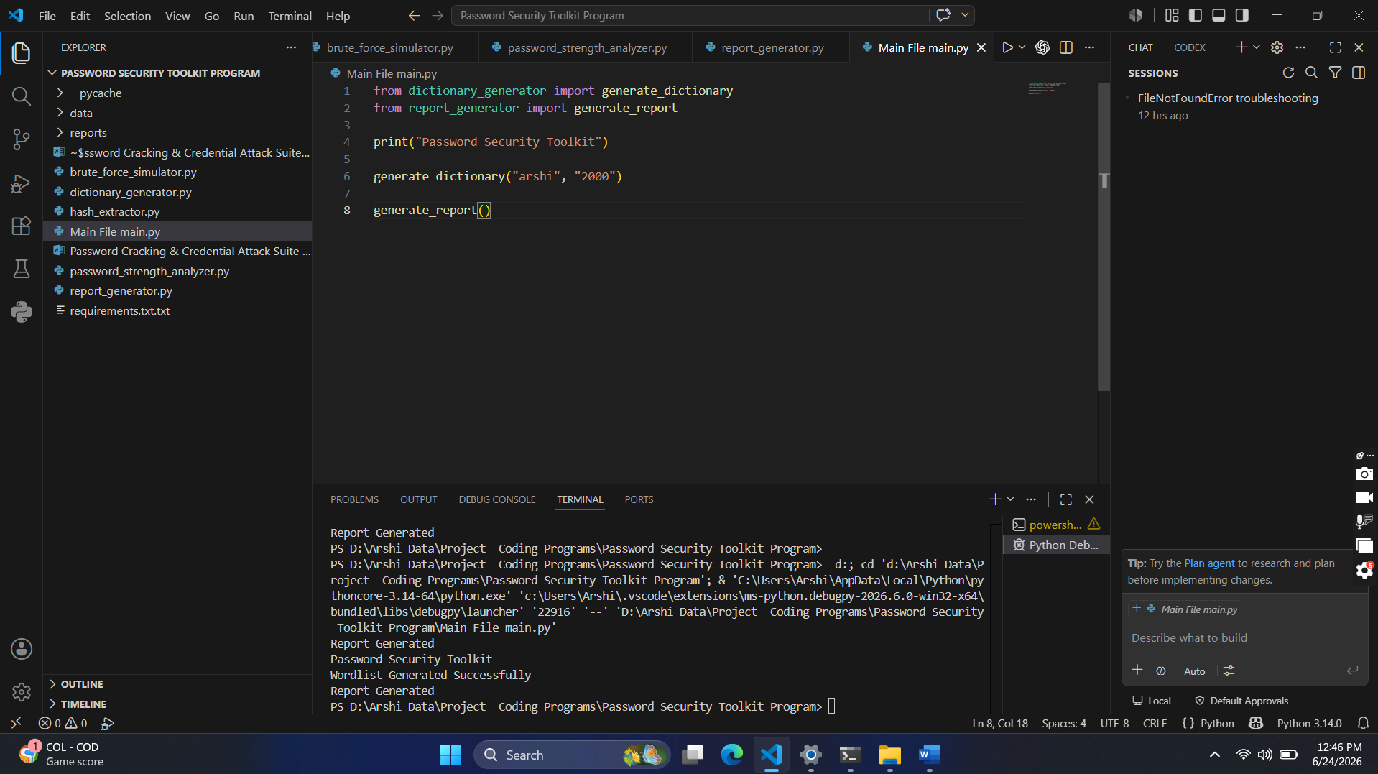

- dictionary_generator.py : The dictionary_generator.py module is responsible for generating a custom password wordlist (dictionary) based on user-provided personal information. This dictionary can be used for password auditing, password security awareness, and demonstrating how attackers create targeted password lists using publicly available information.
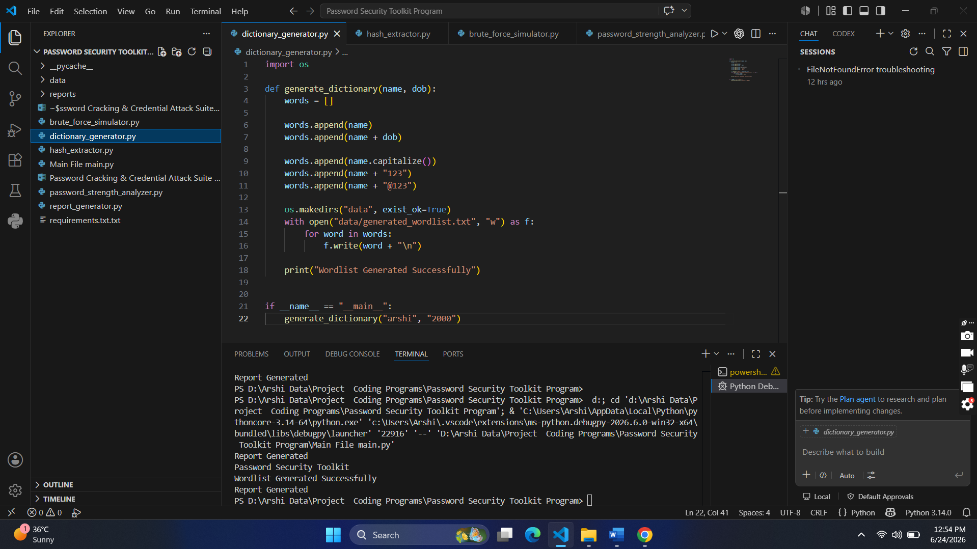

- hash_analyzer.py : The hash_extractor.py module is designed to identify the type of cryptographic hash stored in a text file. It reads hash values from hashes.txt, analyzes their format and length, and determines whether they are likely MD5, SHA-1, or SHA-512 hashes.
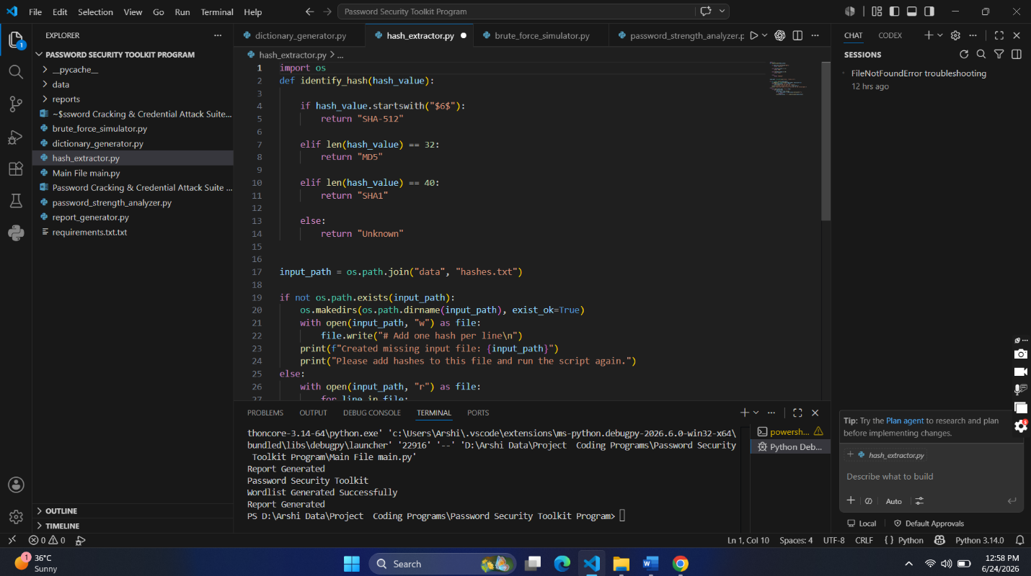
This module demonstrates a common cybersecurity task performed during digital forensics, penetration testing, password auditing, and incident response.

- password_strength_analyzer.py : The password_strength_analyzer.py module evaluates the strength of a password by checking common security requirements such as length, uppercase letters, lowercase letters, numbers, and special characters.
This module helps users understand whether their passwords are secure enough to resist common attacks like brute-force attacks, dictionary attacks, and credential stuffing.
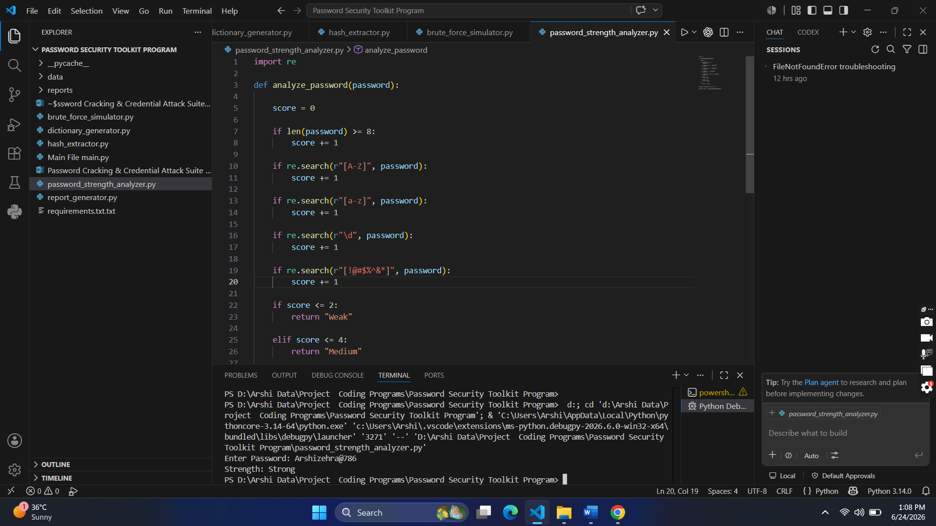

- report_generator.py : The report_generator.py module automatically generates a cybersecurity audit report summarizing the results of the Password Security Toolkit. The report includes the date and time of execution, status of completed security tasks, risk assessment, and password security recommendations.
This module demonstrates automated report generation, a common practice in cybersecurity assessments, penetration testing, and security auditing.
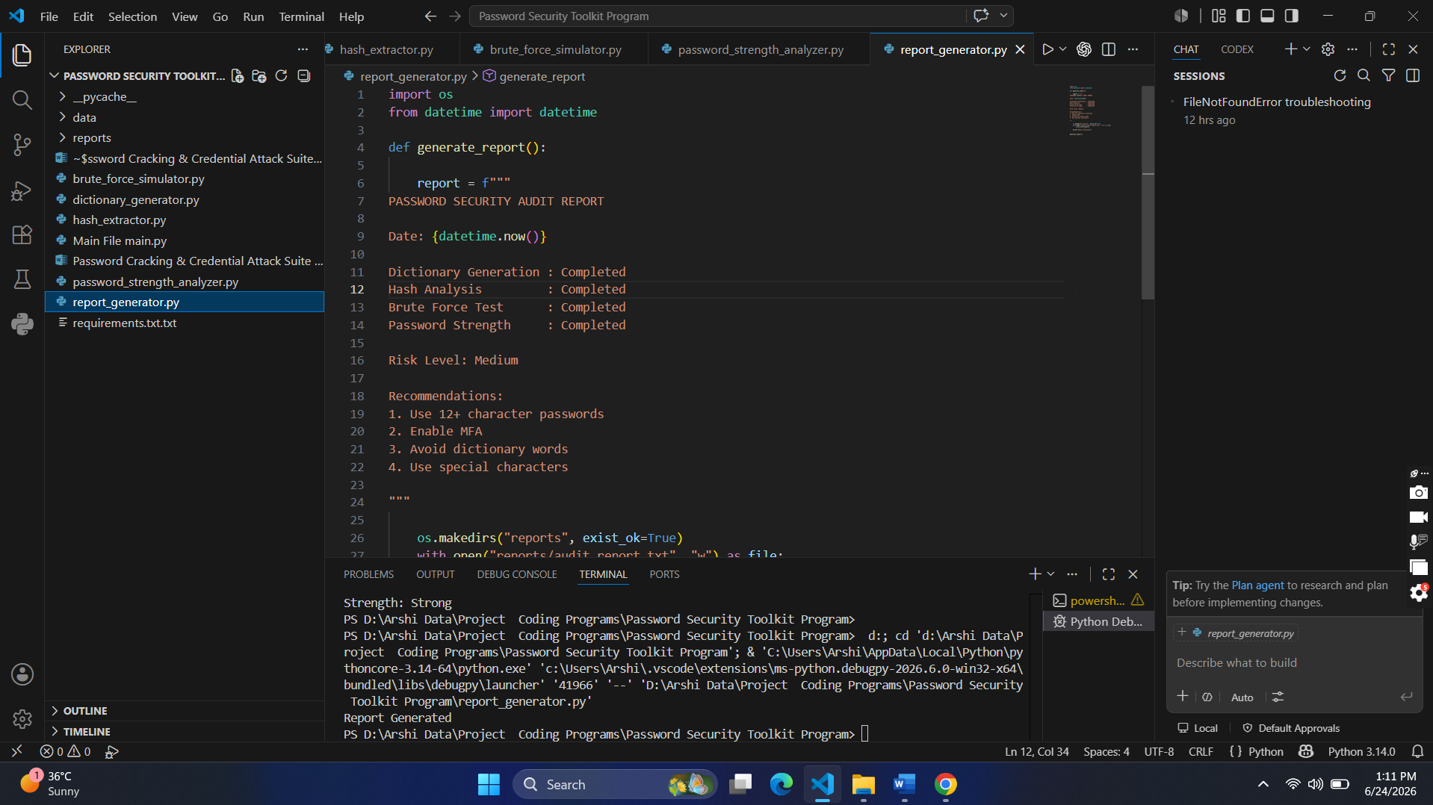

The modular design improves maintainability and scalability.

Testing
The project was tested using multiple password samples.
Example Results:
Password: password123
Strength: Weak
Risk Level: High
Recommendation:
Use a longer password with uppercase letters, numbers, and special characters.

Password: Arshi@2025Secure
Strength: Strong
Risk Level: Low
Recommendation:
Continue using strong password policies and MFA.

Advantages
- Easy to use
- Educational and practical
- Improves password security awareness
- Generates professional reports
- Modular architecture

Limitations
- Designed for educational purposes only
- Limited to password security assessment
- Does not replace enterprise security tools

Future Enhancements
Future versions may include:
- Multi-Factor Authentication assessment
- Password history analysis
- Active Directory integration
- User management dashboard
- Web-based deployment using Streamlit

Learning Outcomes
Through this project, the following concepts were learned:
- Password security fundamentals
- Hashing algorithms
- Authentication security
- Security auditing
- Python programming
- Report generation
- Cybersecurity best practices

Conclusion
The Password Security Audit Toolkit successfully demonstrates password security assessment techniques through password analysis, hash identification, and automated report generation.
The project provides practical experience in cybersecurity auditing and helps users understand secure authentication practices. It serves as an effective educational tool for students and cybersecurity beginners.

References
- Python Official Documentation
- Passlib Documentation
- ReportLab Documentation
- Python-Docx Documentation
- OWASP Password Security Guidelines
- NIST Digital Identity Guidelines

Acknowledgement
I would like to express my sincere gratitude to my faculty members, mentors, and institution for providing guidance and support throughout the development of this project.
Their valuable suggestions and encouragement helped me successfully complete this cybersecurity project.

